WEEK 3 DAY 4
TASK 2

SNOWFLAKE HANDS ON
- Step 1: Create database and schema
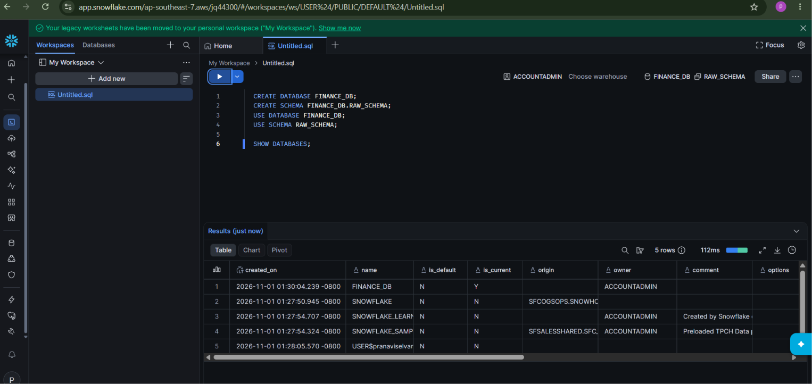

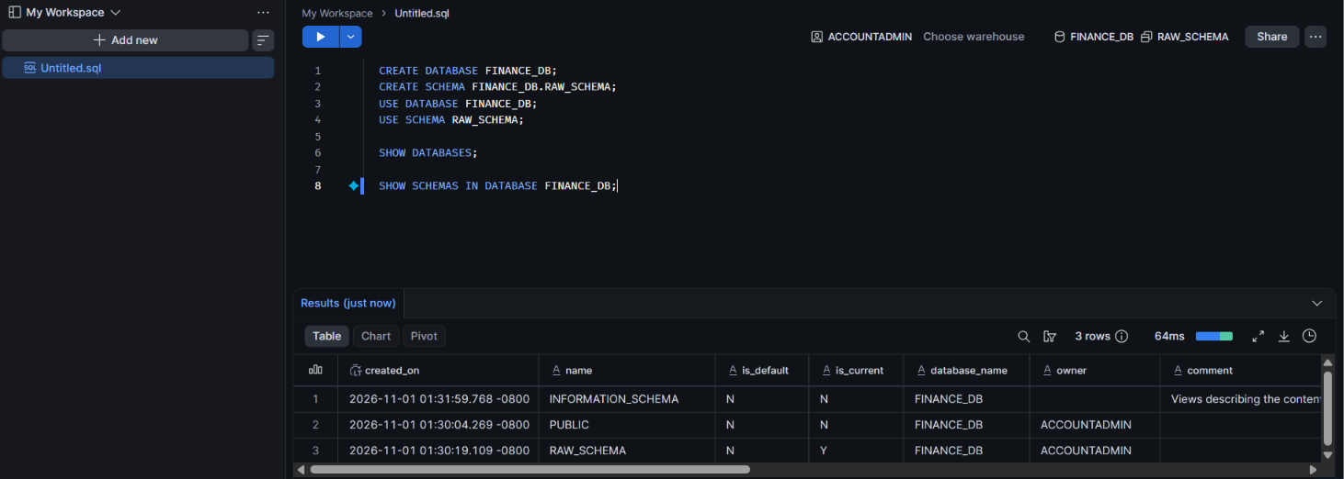

Step 2: Prepare CSV file
Step 3: Create your destination table
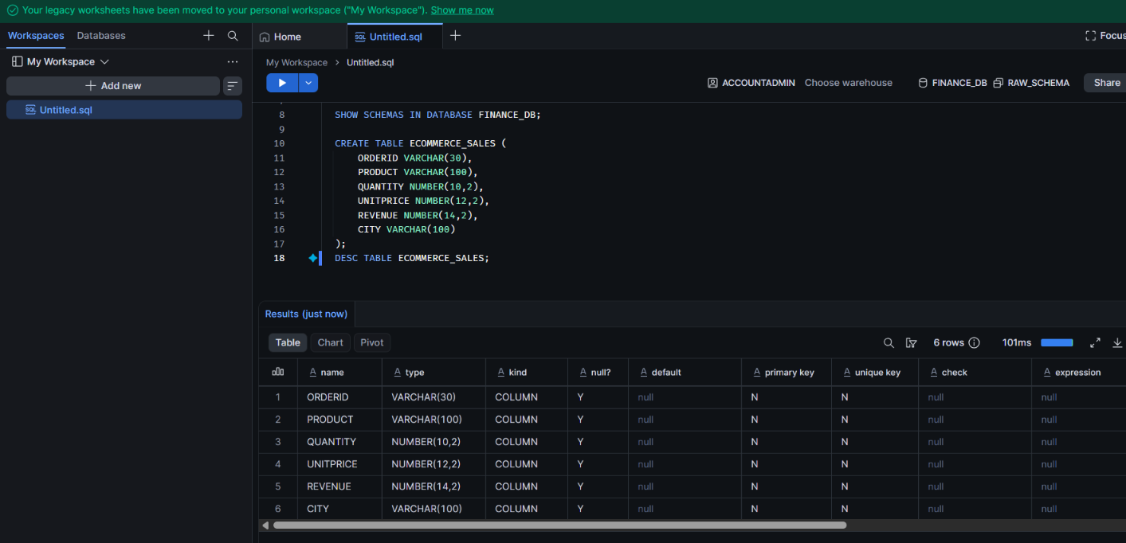
Step 4: Create the CSV file format
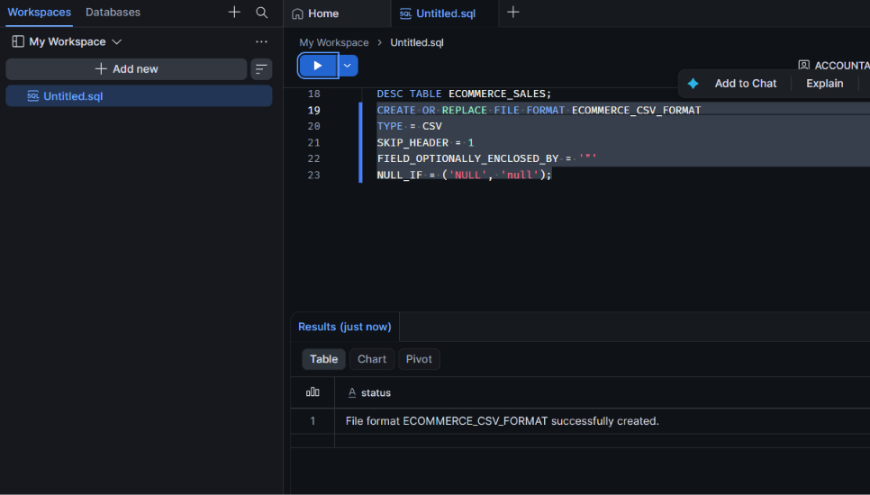
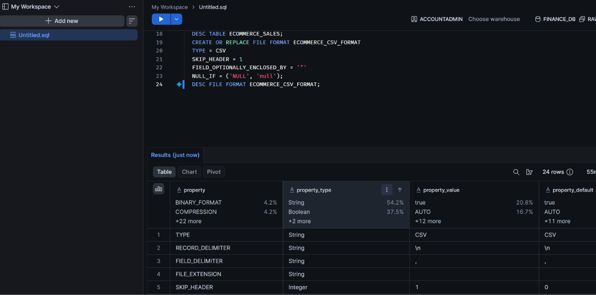

Step 5: Create your stage
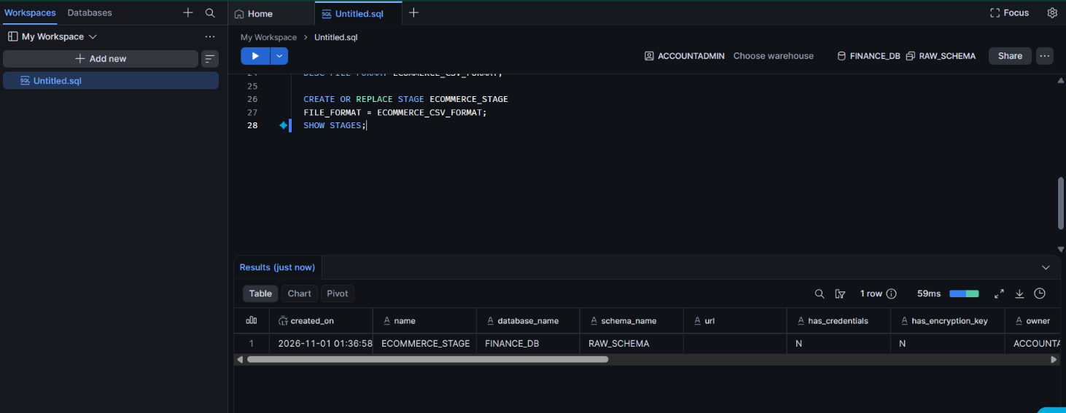
Step 6: Upload CSV
File upload via catolog -db-raw schema
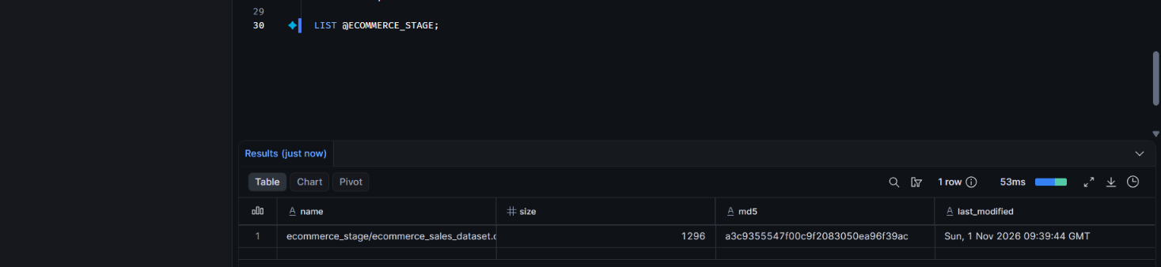

Step 7: creating own warhouse
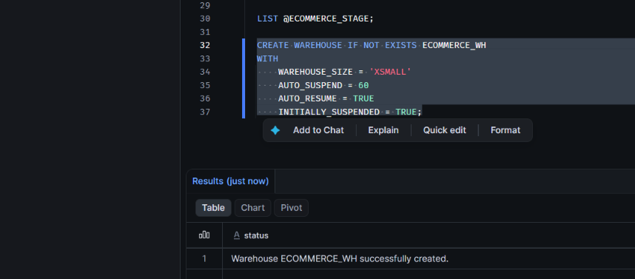
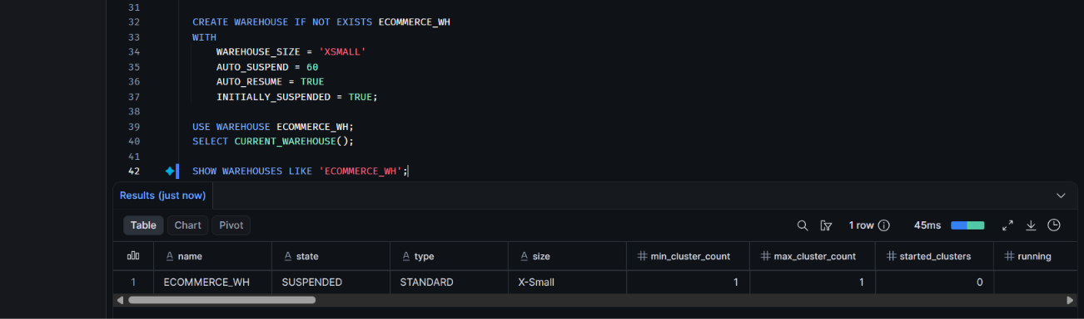

Step 8 : preview csv
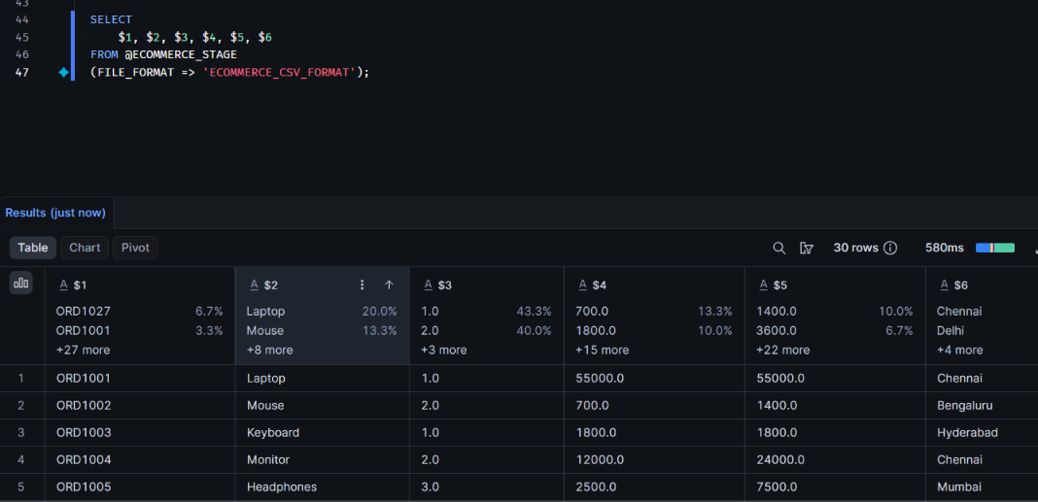
Step 9 : copying the file to destination table
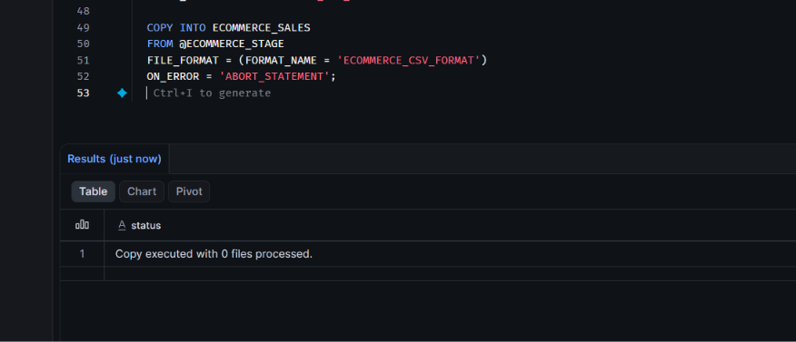

Step 10 : Verifying the data
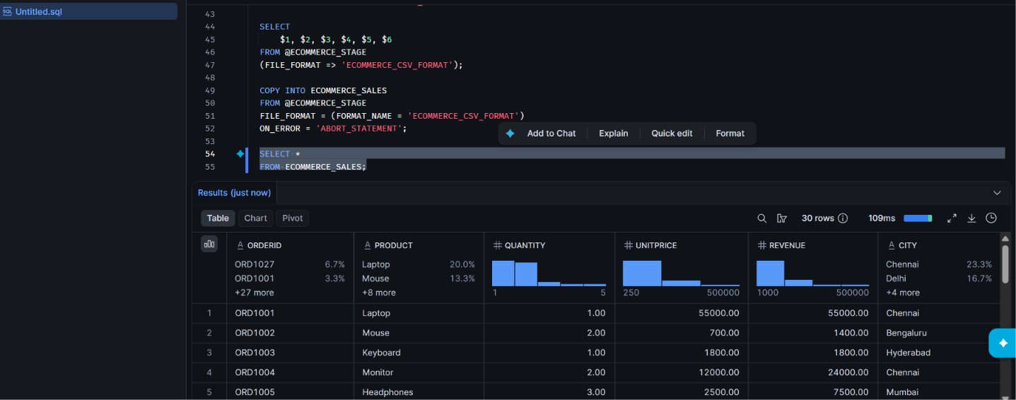

Step 11 : cal tot revenue
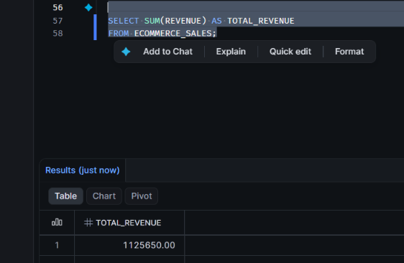

Step 12 : removing and deleting everything

